**Outline:**

A linear 3D Mario inspired platformer with a focus on the jump mechanic. The player has a triple jump combo gaining speed and height with each stage of the jump. The jump is inspired by Mario’s triple jump from Mario 64. The aim of the game is to complete each level under the time limit with the option of collecting coins.

**Jump Mechanic:**

The first jump is just a regular jump.

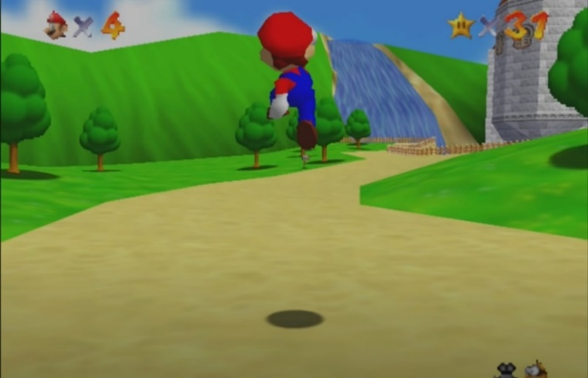

If you jump again right after you hit the ground, you jump higher.

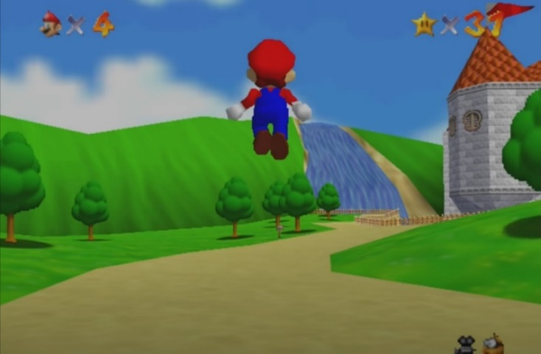

If you jump a third time while moving, you jump even higher. (without the front flip)

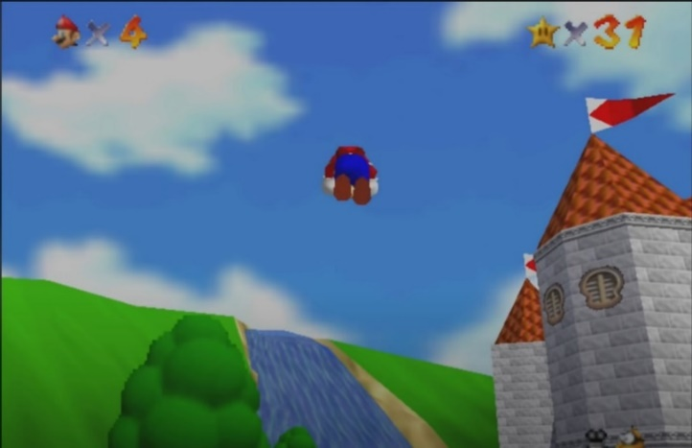

**Level Layout / Structure:**

The level design will be inspired by of Super Mario Bros Wii but in a full 3D environment.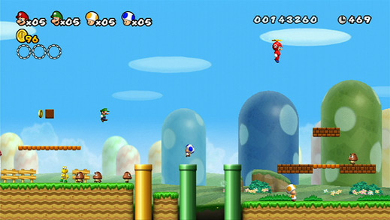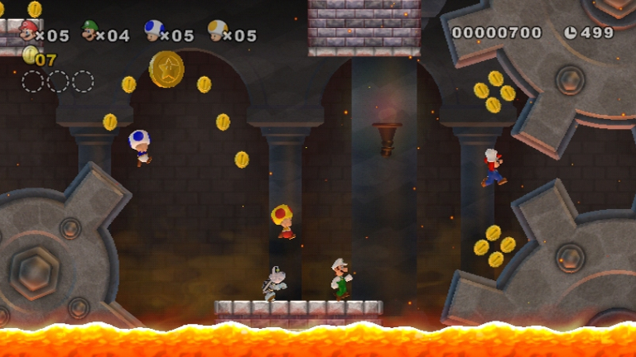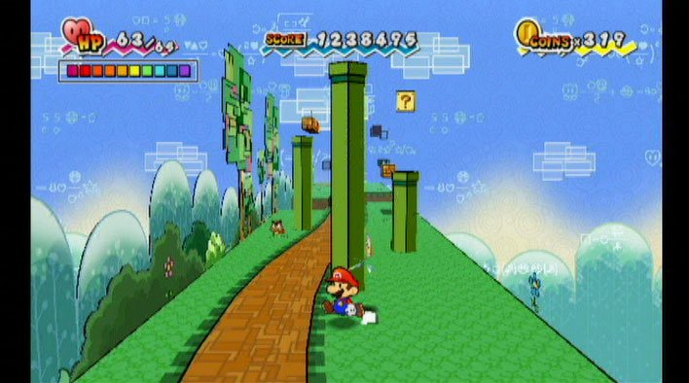

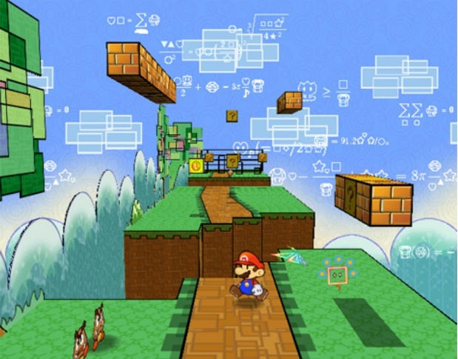

The platforms will have follow a blocky design like in Mario.

**Visual Style:**

Simple, plastic like look.

Objects and the world should look smooth and solid, with little detail, like Lego.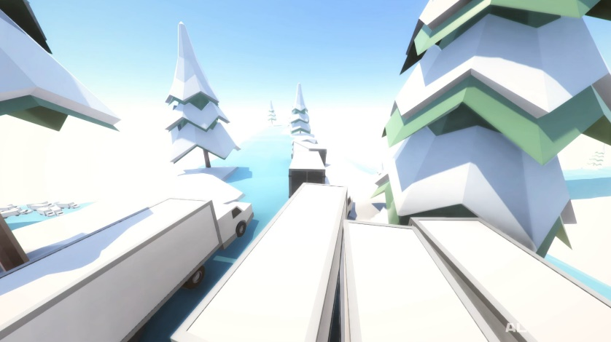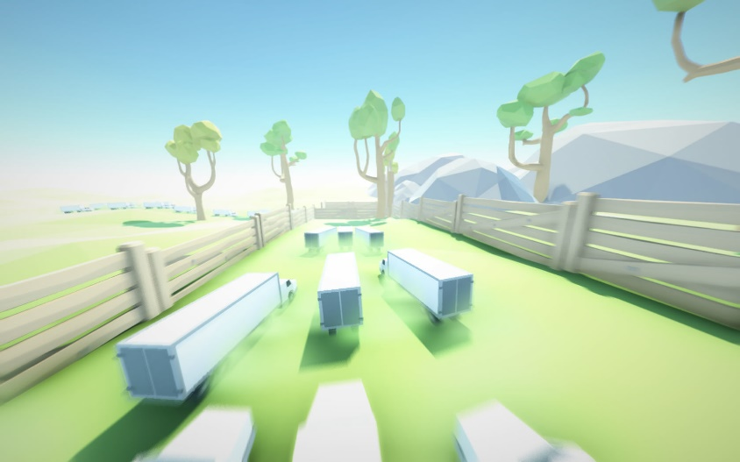

Cluster Truck has a very simple visual style, barely any detail, just simple plain colours, and simple shapes.

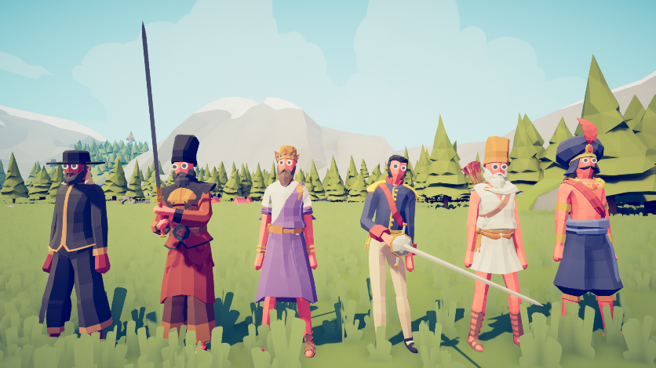

Totally Accurate Battle Simulator also has a very simple, minimal detail, plain colours and simple shapes visual style to it.